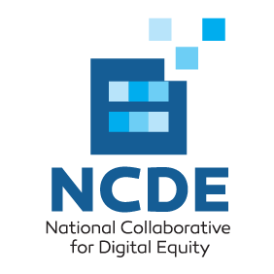

Webinar on Systemic Inclusion: Building Robust Pathways Out of Intergenerational Poverty, June 25th 11AM-noon Eastern

You’re Invited!

Hosted by FDIC and GFE member National Collaborative on Digital Equity, panelists will include:

Celine Coggins CEO, Grantmakers For Education
David Rothstein Director for BankOn, Cities for Financial Empowerment Fund
Gonzalo Puigbo Vice President, Community Reinvestment Act Compliance, People’s
United Bank
Robert McLaughlin Executive Director, National Collaborative for Digital Equity

Terry Lee Webinar moderator, Community Affairs Specialist, FDIC

This interactive webinar will explore the need for collaboration among investors in economic (e.g., bank Community Reinvestment Act compliance executives) and educational opportunity (e.g., education funders) in building robust, systemic pathways for children, youths and adults out of intergenerational poverty. NCDE has developed a conceptual framework of “systemic inclusion” – financial, economic, educational and digital – to guide its efforts. Panelists will share strategies they have undertaken and challenges they have encountered to foster key dimensions of local systemic inclusion in high poverty communities. Webinar participants will be encouraged to join in shaping efforts to pilot, assess, refine, and sustain systemic inclusion partnerships that assist low-income learners of all ages to persist and prevail. The webinar is intended for all interested stakeholders including:

- Education funders
- Bank CRA compliance executives
- Workforce development leaders
- Educational system leaders
- Learning technology and digital inclusion leaders
- Resource providers for financial, economic, educational and digital inclusion

To register please RSVP here. For more information, please contact Dr. Robert McLaughlin.

