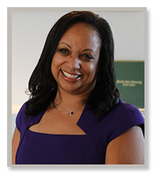

Dr. Arletha McSwain is the Executive Director for B-CU Global Online Partnerships and Deputy Title IX Coordinator for Faculty and Staff at Bethune Cookman University. Her dedication to Open Education Resources (OER) and distance learning is exemplary. In 2017, Dr. McSwain was inducted into the United States Distance Learning Association (USDLA) Hall of Fame and in 2018 became a member of the Board of Directors for USDLA.

She is a nationally known content expert on issues related to early childhood education, and early childhood special education while targeting males of diversity. She has written numerous successful grant proposals totaling over $6 million dollars Dr. McSwain graduated from the University of Missouri-Columbia with a Ph.D. in Early Childhood Special Education.

