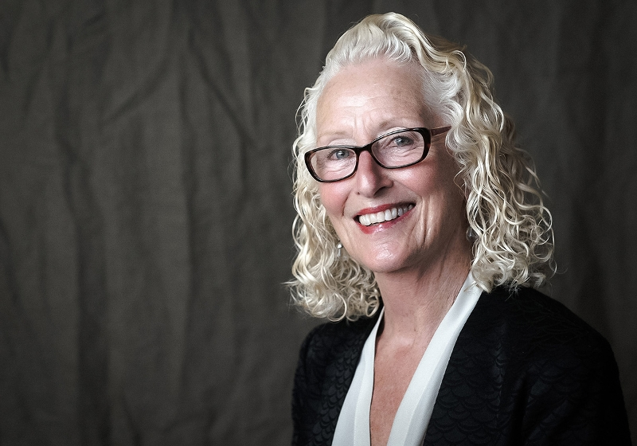 Wendy Keeney

Wendy oversees all efforts large and small across the organization to build a pipeline of diverse funding opportunities for CAST and a robust portfolio.She comes to CAST with 26 years of experience managing every aspect of large grant programs, philanthropic outreach, marketing/communications, and business development. She has conceived and executed capital campaigns, as well as created development operations from the ground up.

